The Secret Life of XY Monitors

By Jed Margolin

During my time at Atari/Atari Games I worked on several XY games. This article represents what I know about XY Monitors. XY was Atari's name for what the Computer Graphics industry calls '"Random Scan" and the Video Game Community calls "Vector Games." The major parts of the XY Monitor are the Cathode Ray Tube (CRT), the Deflection Amplifiers, and the High Voltage Supply.

XY Monitors - Contents

1. CRT Electron Optics

2. Deflection Types
A. Electrostatic
B. Magnetic

3. XY - Deflection Amplifiers

4. High Voltage Power Supplies

5. Screen Phosphors

6. Color CRTs

7. Alternatives

8. References
_________________________________________________________________________________________

CRT Electron Optics

The CRT is an evacuated container with an Electron Gun that shoots a focused electron beam at a phosphor-coated screen which absorbs the energy of the electrons and re-emits it as visible light. The High Voltage Supply produces the voltage needed to accelerate the electron beam toward the screen. The Deflection Amplifiers move the electron beam in the desired pattern.

We will start with the CRT shown in Figure 1.

When metal is heated to incandescence in a vacuum the electrons near the surface are given enough energy to fly off into the surrounding space.

The Electron Gun starts with the Heater (or Filament) which uses an electric current in order to heat it up to incandescence. However, instead of using the Heater to directly produce electrons, it heats up a separate element, the Cathode, to produce the electrons. One reason for doing it this way is that it allows the Heater supply to be electrically isolated from the Cathode. This keeps the Cathode voltage out of the Heater supply, allowing it to be used for other things as well. It's also a safety issue, since the Cathode voltage might be
substantial. I suspect that another reason for using an indirectly heated cathode is that it allows the Heater to be optimized for long life and the Cathode optimized for emitting electrons.

The Control Grid (called G1) is operated with a negative bias with respect to the Cathode (typically around 50V.) and acts to repel the electrons coming from the Cathode.

The reason for doing this is that the Screen Grid (G2) is operated at a voltage that is higher than the Cathode (typically several hundred volts). The physics works out that a small change in the Control Grid voltage has a large effect on the electron beam current.

The electron beam is further accelerated by Focus Grid (G3) which is operated at an even higher voltage (typically several thousand volts). As you may have guessed, the Focus Grid also focuses the beam.

The final acceleration comes from an even higher voltage on the Anode (typically several times the voltage on the Focus Grid).

The resulting beam strikes the phosphor-covered screen which absorbs the energy of the electrons and re-emits it as visible light.

The equations that describe the motion of electrons in a potential field take the same form as those used to describe the behavior of optical lenses. The shape of the electron beam on the screen is an image of the electron beam at what is called the crossover point, which is the place in the electron gun where the grids cause the electrons to change velocity. The ratio of the voltage at the Focus Grid (G3) relative to the voltage at the Anode controls the crossover point and therefore the point at which the image is focused, much the same way as the curvature of an optical lens determines its focal point.

This is why it is called electron optics.

A further note about the grid structures. While standard vacuum tubes (both receiving and transmitting types) use grids in the form of a mesh, the grids in a CRT are cylinders. In addition, the Control Grid (G1) also contains a disk with a hole in the middle called the Aperture Disk. ( See Figure 2). This helps produce a narrow electron beam

Now that we have a nice focused electron beam hitting the phosphor we should probably move it around before we burn the screen.

Electrostatic Deflection

Two pairs of parallel plates are mounted in the CRT. A voltage applied across the Vertical Plates will deflect the electron beam vertically as shown in Figure 3. A voltage applied across the Horizontal Plates will deflect the electron beam horizontally. (One of the Horizontal Plates in Figure 3 is hidden by its mate.)

The deflection of the beam in an electrostatically deflected CRT is given (from Whitaker) by:

Vd * dl
tan(da) = __________

2 * dp * Vb

where: Vd = the voltage between the deflection plates
dl = the length of the plates
dp = the distance between the plates
Vb = beam voltage

Since the construction of the plates (dl and dp) is determined by the CRT manufacturer we will simplify things by letting K1 = dl/(2*dp) so that:

tan(da) = K1 * Vd / Vb

Therefore, the tangent of the deflection angle is proportional to the voltage between the plates and inversely proportional to the beam voltage (Anode voltage).

From Figure 3:
tan(da) = db/L

L is another value determined by the CRT manufacturer, so that the deflection of the beam is given by:

db = K2 * Vd / Vb where K2 = L * dl/(2*dp)

The good news is that the screen deflection of the beam is proportional to the voltage between the plates.

The bad news is that it is inversely proportional to the Anode voltage. This means that if we double the Anode voltage we have to double the voltage between the plates for the same beam deflection. If the voltage between the deflection plates is already 200V, then we would need to increase it to 400V for the same deflection. Although that would not be too much of a problem with today's components, the deflection amplifiers would now also require twice the slew rate if we are to move the beam at the same speed.

Why not just use a low Anode voltage?

First, Anode voltages have to be high just to get acceptable screen brightness.

And second, the Anode voltage has an effect on the beam focusing. As the Anode voltage is increased, the electron beam can be focused to a smaller spot size.

For these reasons, electrostatic CRTs are used mostly in oscilloscopes where speed is important and screens are small.

Magnetic Deflection

An electron beam is deflected when it moves through a magnetic field. In a CRT with magnetic deflection, instead of two pairs of deflection plates inside the CRT, there are two pairs of deflection coils mounted around the neck. The two pairs of coils are mounted at right angles to provide X and Y deflection. As a side note, an electron beam is deflected at right angles to the applied magnetic field, so that the coils that are mounted on either side of the neck (horizontally) deflect the beam vertically; the coils that are mounted vertically deflect the beam horizontally.

The deflection of the beam is given (from Whitaker) by the formula:

sin(da) = (2.97*10**5) * L * Bm / (V**0.5)

Let's simplify it by letting K3 = (2.97*10**5) * L, so that

sin(da) = K3 * Bm / (V**0.5)

where: Bm is the magnetic field
V is the Anode voltage

Further, in a properly designed coil, the magnetic field (Bm) is proportional to the electric current in the yoke coils so we can say:

sin(da) = K4 * I / (V**0.5)

Again, there is good news and bad news.

The good news is that the deflection is proportional to the inverse square root of the Anode voltage, as opposed to the straight inverse in the electrostatic CRT. This means that if we double the Anode voltage we only have to increase the yoke current by a factor of 1.414 . (The electron optics relating Anode voltage to spot size are the same as for the electrostatic CRT. A higher Anode voltage produces a smaller spot size.)

The bad news is that the deflection on the screen (db) is going to be the tangent of the arcsin of the yoke current. You can see this is Figure 4 where

tan(da) = db/L

so that
db = L* tan(da)

For angles of less than 30 degrees, sin(angle) is approximately equal to the angle in radians. This is shown in Figure 5.

Likewise, for angles of less than 30 degrees, tan(angle) is approximately equal to the angle in radians. This is shown in Figure 6.
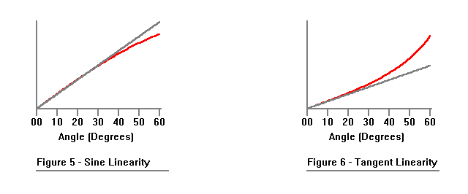
If we keep our deflection angle less than 30 degrees we'll be ok. That would mean using a 60 degree CRT (plus and minus 30 degrees).

Unfortunately, that was not a standard type for the sizes we wanted to use (13", 19", and later, 25"). The way CRTs were made (and probably still are) is that once a year Corning guessed how many CRTs the TV industry would need for the next year. They would then build that many CRT envelopes in a single run, and that would be it for the year. The CRT envelopes were then sold to the CRT manufacturers. Corning must have been good at estimating the need because I don't remember there ever being a CRT shortage.

Standard CRTs come in 90 degree, 100 degree, and 110 degree deflection angles. This is because the larger the deflection angle, the shorter the CRT envelope. These deflection angles came about because people don't want the backs of their TVs to stick out a lot.

Therefore, for a 90 degree (or more) CRT we have to deal with the deflection nonlinearity.

The deflection nonlinearity is actually worse than you might think and is entirely the fault of geometry. The reason is that there is only one electron beam, and it can only be deflected at one angle at a time.

Figure 7a represents the geometry of a beam aimed at the center of the screen. The face of the screen is shown in Figure 7b.

If we deflect the beam along only the X axis (Figure 8a) the deflection angle to produce a screen deflection of dx will be atan(dx/L).

However, as shown in Figure 9, if we want to produce a deflection of both X and Y axes (dx and dy respectively) , the deflection angle will be atan(dr/L). Since dr is larger than either dx or dy, the deflection angle will also be larger.

This is a problem, especially at the corners of the screen where the deflection angles are the largest. Remember Figure 6. The larger the deflection angle, the farther we are operating in the nonlinear part of the tangent function.

You may have heard of pincushion distortion. Now you know what causes it.

Figure 10 shows the uncorrected distortion for a 60 degree CRT.

Figure 11 shows how much worse it is for a 90 degree CRT.

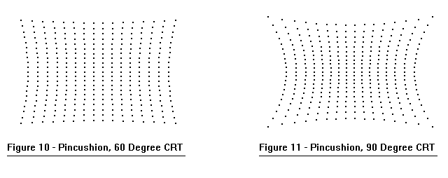

There is an additional factor that causes geometric distortion.

So far, our analyses have assumed a perfectly flat screen. While CRTs with perfectly flat screens are available today, they weren't available in the 1980s. This was before even almost-flat screens. On this one we will leave out the math and just show Figure 12.

The reason for the curved screen is that curved screens are better able to withstand the large forces produced by the vacuum inside the envelope. After all, this is a vacuum tube.

Now that we have shown the causes of pincushion distortion, what are we going to do about it?

According to Grob (page 220):

"For monochrome picture tubes, the pincushion distortion is corrected by permanent magnets mounted on the housing of the deflection yoke. These pincushion magnets cannot be used with color picture tubes, however, because they would affect the three beams by different amounts, resulting in more problems with color purity and convergence. Therefore, dynamic pincushion correction is used with color picture tubes."

Indeed, the Electrohome GO5 Monochrome X-Y Monitor ("Quadrascan") used in Lunar Lander, BattleZone, and Red Baron used magnets on the yoke housing to provide pincushion correction.

According to Whitaker (page 234):

"Pincushion correction is used in all wide-angle deflection systems. This correction may be achieved by one of the following"

A special yoke design that has controlled field distortion.

Predistorting the deflection current and applying it to a separate pincushion transformer that connects the correction current to the vertical yoke."

Whitaker's reference to a pincushion transformer shows an obvious bias toward raster scan displays. An XY display would use a circuit to predistort the deflection currents.

Also bear in mind that the Grob reference is from 1975. Perhaps the method of using special yoke design to produce a controlled distortion to provide pincushion correction came later.

Normally, pincushion correction is performed in the monitor. However, Atari's first color XY games (Tempest, Space Duel, Gravitar, and Black Widow) did pincushion correction on the game board.

Here's how it was done.

Now you know what the MC1495 analog multipliers were for.

The following is a more complete schematic of the circuit.

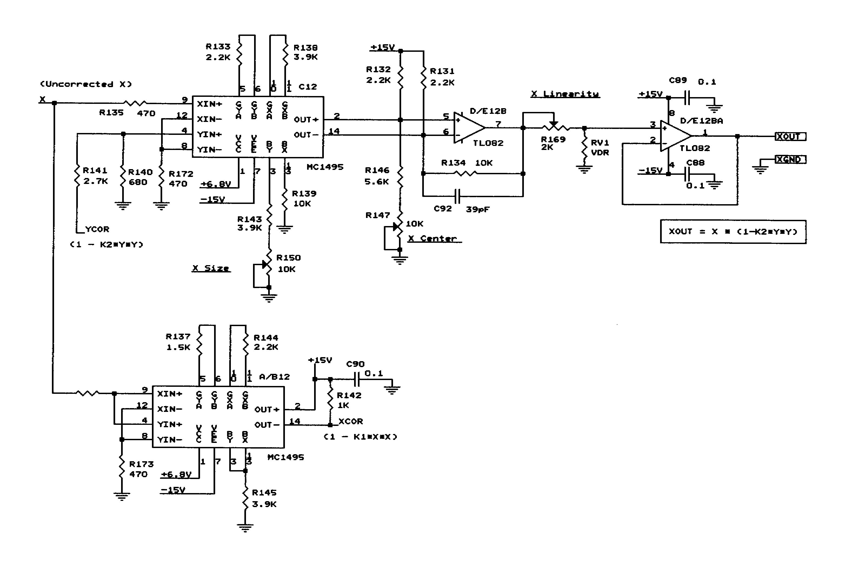
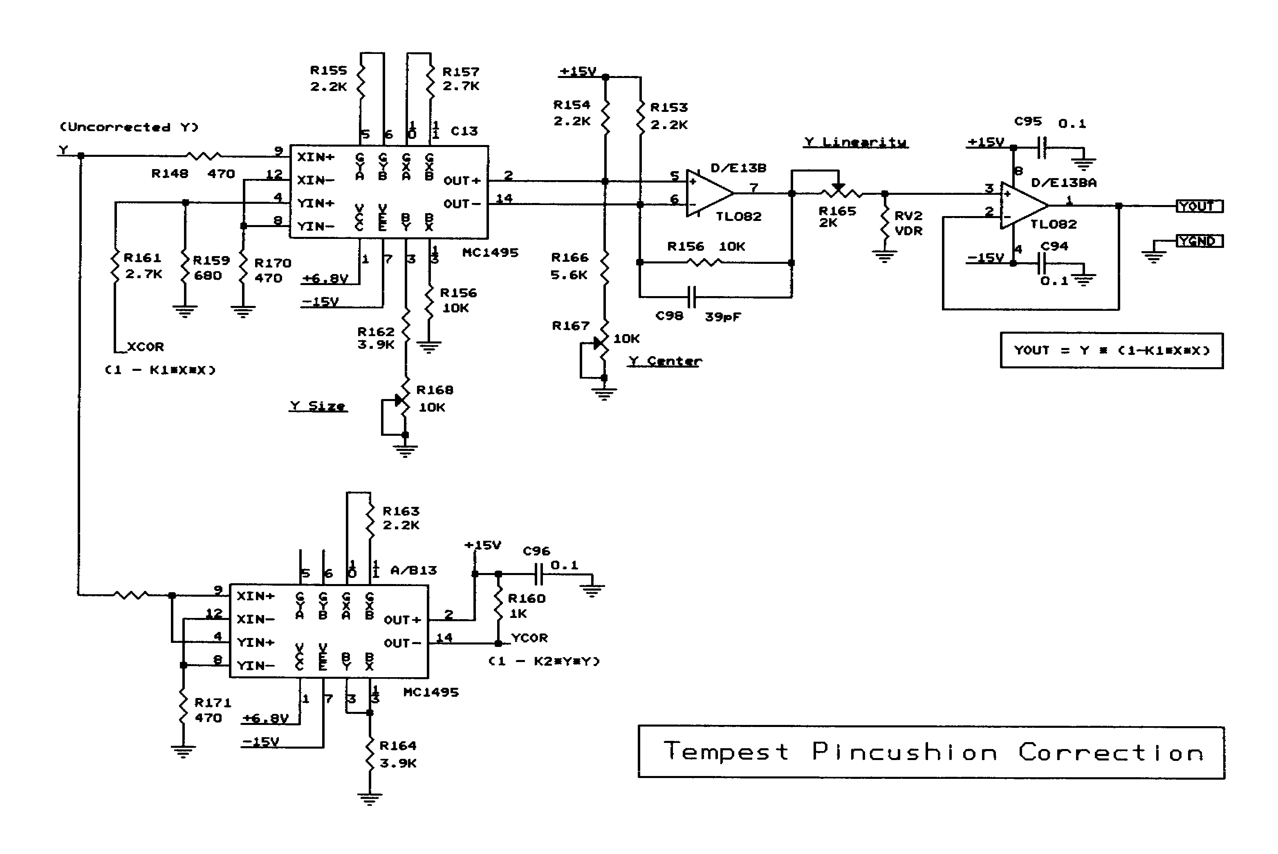

In Atari's last color XY games (Star Wars and Major Havoc) pincushion correction was done in the monitor using a specially designed yoke.

XY Deflection Amplifiers

We have gotten to the point where the currents in the X and Y deflection coils will move the electron beam around the screen in a linear fashion.

Now we have to produce the current.

Since the output of the Vector Generator will be a voltage, the Deflection Amplifier will convert a voltage to a current (which will be substantial). To do this will require a foray into Control Theory.

A standard feedback control network has the following form:

The Gyrator takes the difference between the positive and negative inputs and produces output Y.

The Gain Block amplifies its input Y by a factor of A to produce output Vout.

Output Vout is fed back to the negative input of the Gyrator using Transfer Function H.

Now some simple math.

Y = Vin - Vout * H

Vout = A * Y

Therefore:

Vout = A * Y
= A * (Vin - Vout*H)
= A * Vin - A*Vout*H

Vout + A*Vout*H = A*Vin

Vout *(1+A*H) = A*Vin

A*Vin
Vout = --------------
(1 + A*H)

Vin
Vout = ------------- Equation 1
(1/A + H)

If A is sufficiently large, 1/A = 0, so that

Vout = Vin/H Equation 2

The next thing is to notice that the Gyrator and Gain Block in Figure 14 looks a lot like an Op-Amp. The main difference is that Output Y is not generally accessible. (That's ok, Output Y has served its purpose.)

Let's try a Transfer Function H in the form of a simple resistor divider where H = R1/(R1+R2).

From Equation 2:

Vout = Vin * 1/H

1
= Vin * --------------
R1/(R1+R2)

(R1+R2)
= Vin * -------------
R1

= Vin * (1 + R2/R1)

which turns out to be the gain for a op-amp non-inverting amplifier.

The next thing to recognize is that the voltage across R1 is Vin.

After all, Vout = Vin/H and VR1 = Vout * H, so that VR1 = Vin/H * H = Vin .

Therefore, the current through R1 is just Vin/R .

Assuming that the input currents to the op-amp are negligible (which is usually a good bet) the current through R2 is the same as the current through R1. There's no other place for it to go.

This means we can use Vin to control the current through R2. Of course, that assumes the op-amp can supply the necessary current and voltage.

The deflection amplifiers used in the XY monitors used in Star Wars supply about 2 Amps for full deflection. (The deflection amplifiers are not TL082s.)

What if R2 is not a resistor at all, but, for example, an inductor such as shown in Figure 18?

(The deflection windings have an internal resistance which is not shown. The Vertical windings have an internal resistance of 1.1 Ohms while the Horizontal windings have a resistance of 1.9 Ohms, which is probably because the windings are concentric and the Horizontal windings are on the outside. Both Horizontal and Vertical deflection windings have an inductance of about 1 mH.)

The current through L is still the same as the current through R1. The only difference is that the impedance of L is frequency dependent. In the time domain an inductance resists having its current changed. The op-amp provides persuasion by giving it a good swift voltage kick.

Figure 19 shows the voltage across the sense resistor (top trace) and voltage to the deflection yoke coil (bottom trace). We are on the X axis with a monitor test screen (not shown) that draws a box all the way around the screen. (It's from the BIP test.)

1. The vector starts out being drawn to the right. The op-amp kicks it to get it going. Once it gets going it needs very little additional voltage to develop the current ramp in the yoke.

2. When the vector stays in one place (because the Y axis is being ramped) the X axis op-amp requires much less voltage to maintain the yoke current.

3. When the vector is being drawn to the left, the op-amp gives it a negative kick to get it going. Once it starts going it needs very little additional voltage to develop the current ramp in the yoke.

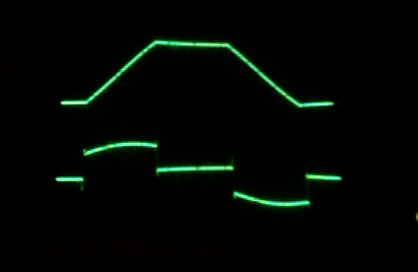
Figure 19 - Amplifone

Voltage across the current sense resistor + 2.5 Volts to -2.5 Volts

Output of Deflection Amplifier
+20 Volts to -20 Volts

And, finally, a word about the current sense resistor. It is important that this resistor be non-inductive. Otherwise, the deflection sensitivity will change with frequency. For a bunch of vectors of random length the result will be unpredictable, although short vectors will probably be shorter than they should be and long vectors will be too long. This kind of problem we don't need.

Since the current sense resistor needs to dissipate more power than a carbon resistor can handle we are left with a wirewound resistor. A standard wirewound resistor is just an appropriate length of resistance wire wound around a core. See Figure 20a. This fits the definition of an inductor.

In a non-inductive wirewound resistor, there are two windings wound on the core in opposite directions and connected in parallel. The magnetic fields produced by the coils cancel and thus the inductances cancel. See Figure 20b. (Of course, even a straight wire has some inductance.) A non-inductive resistor has about 1% of the inductance of a standard wound resistor of the same size.

And, further, because the windings are connected in parallel, it's ok for each segment to be connected in parallel so it is not necessary to use insulated wire.

The Amplifone Deflection Amplifiers also contain a circuit that looks at activity on the X and Y inputs. If it doesn't find what it feels is an appropriate amount of activity it turns off the Beam to prevent it from burning up the screen phosphor. This is the infamous Spot Killer.

Even with the Spot Killer, screen phosphor burn was a common occurrence during software development. One time I saw a runaway Vector Generator burn off the phosphor in the middle of the screen, then burn completely through the shadow mask, and start to burn through the glass.

Here are the full schematics for the Amplifone XY Monitors, followed by the schematics for the Wells-Gardner XY Monitor.

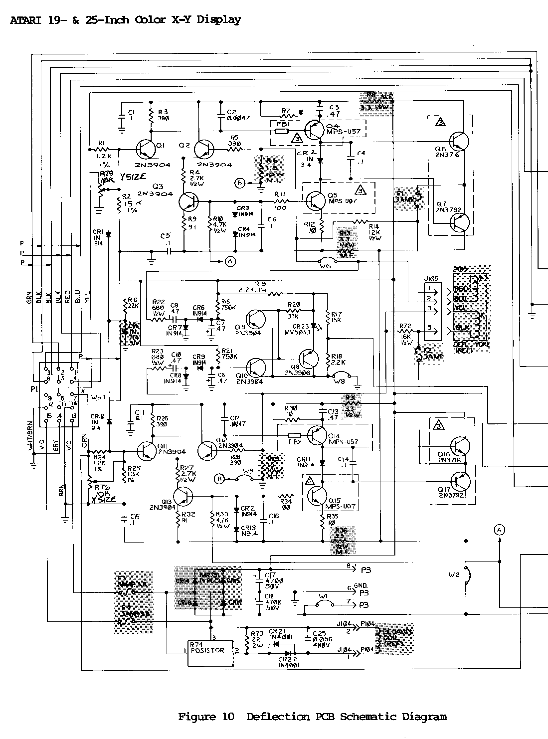
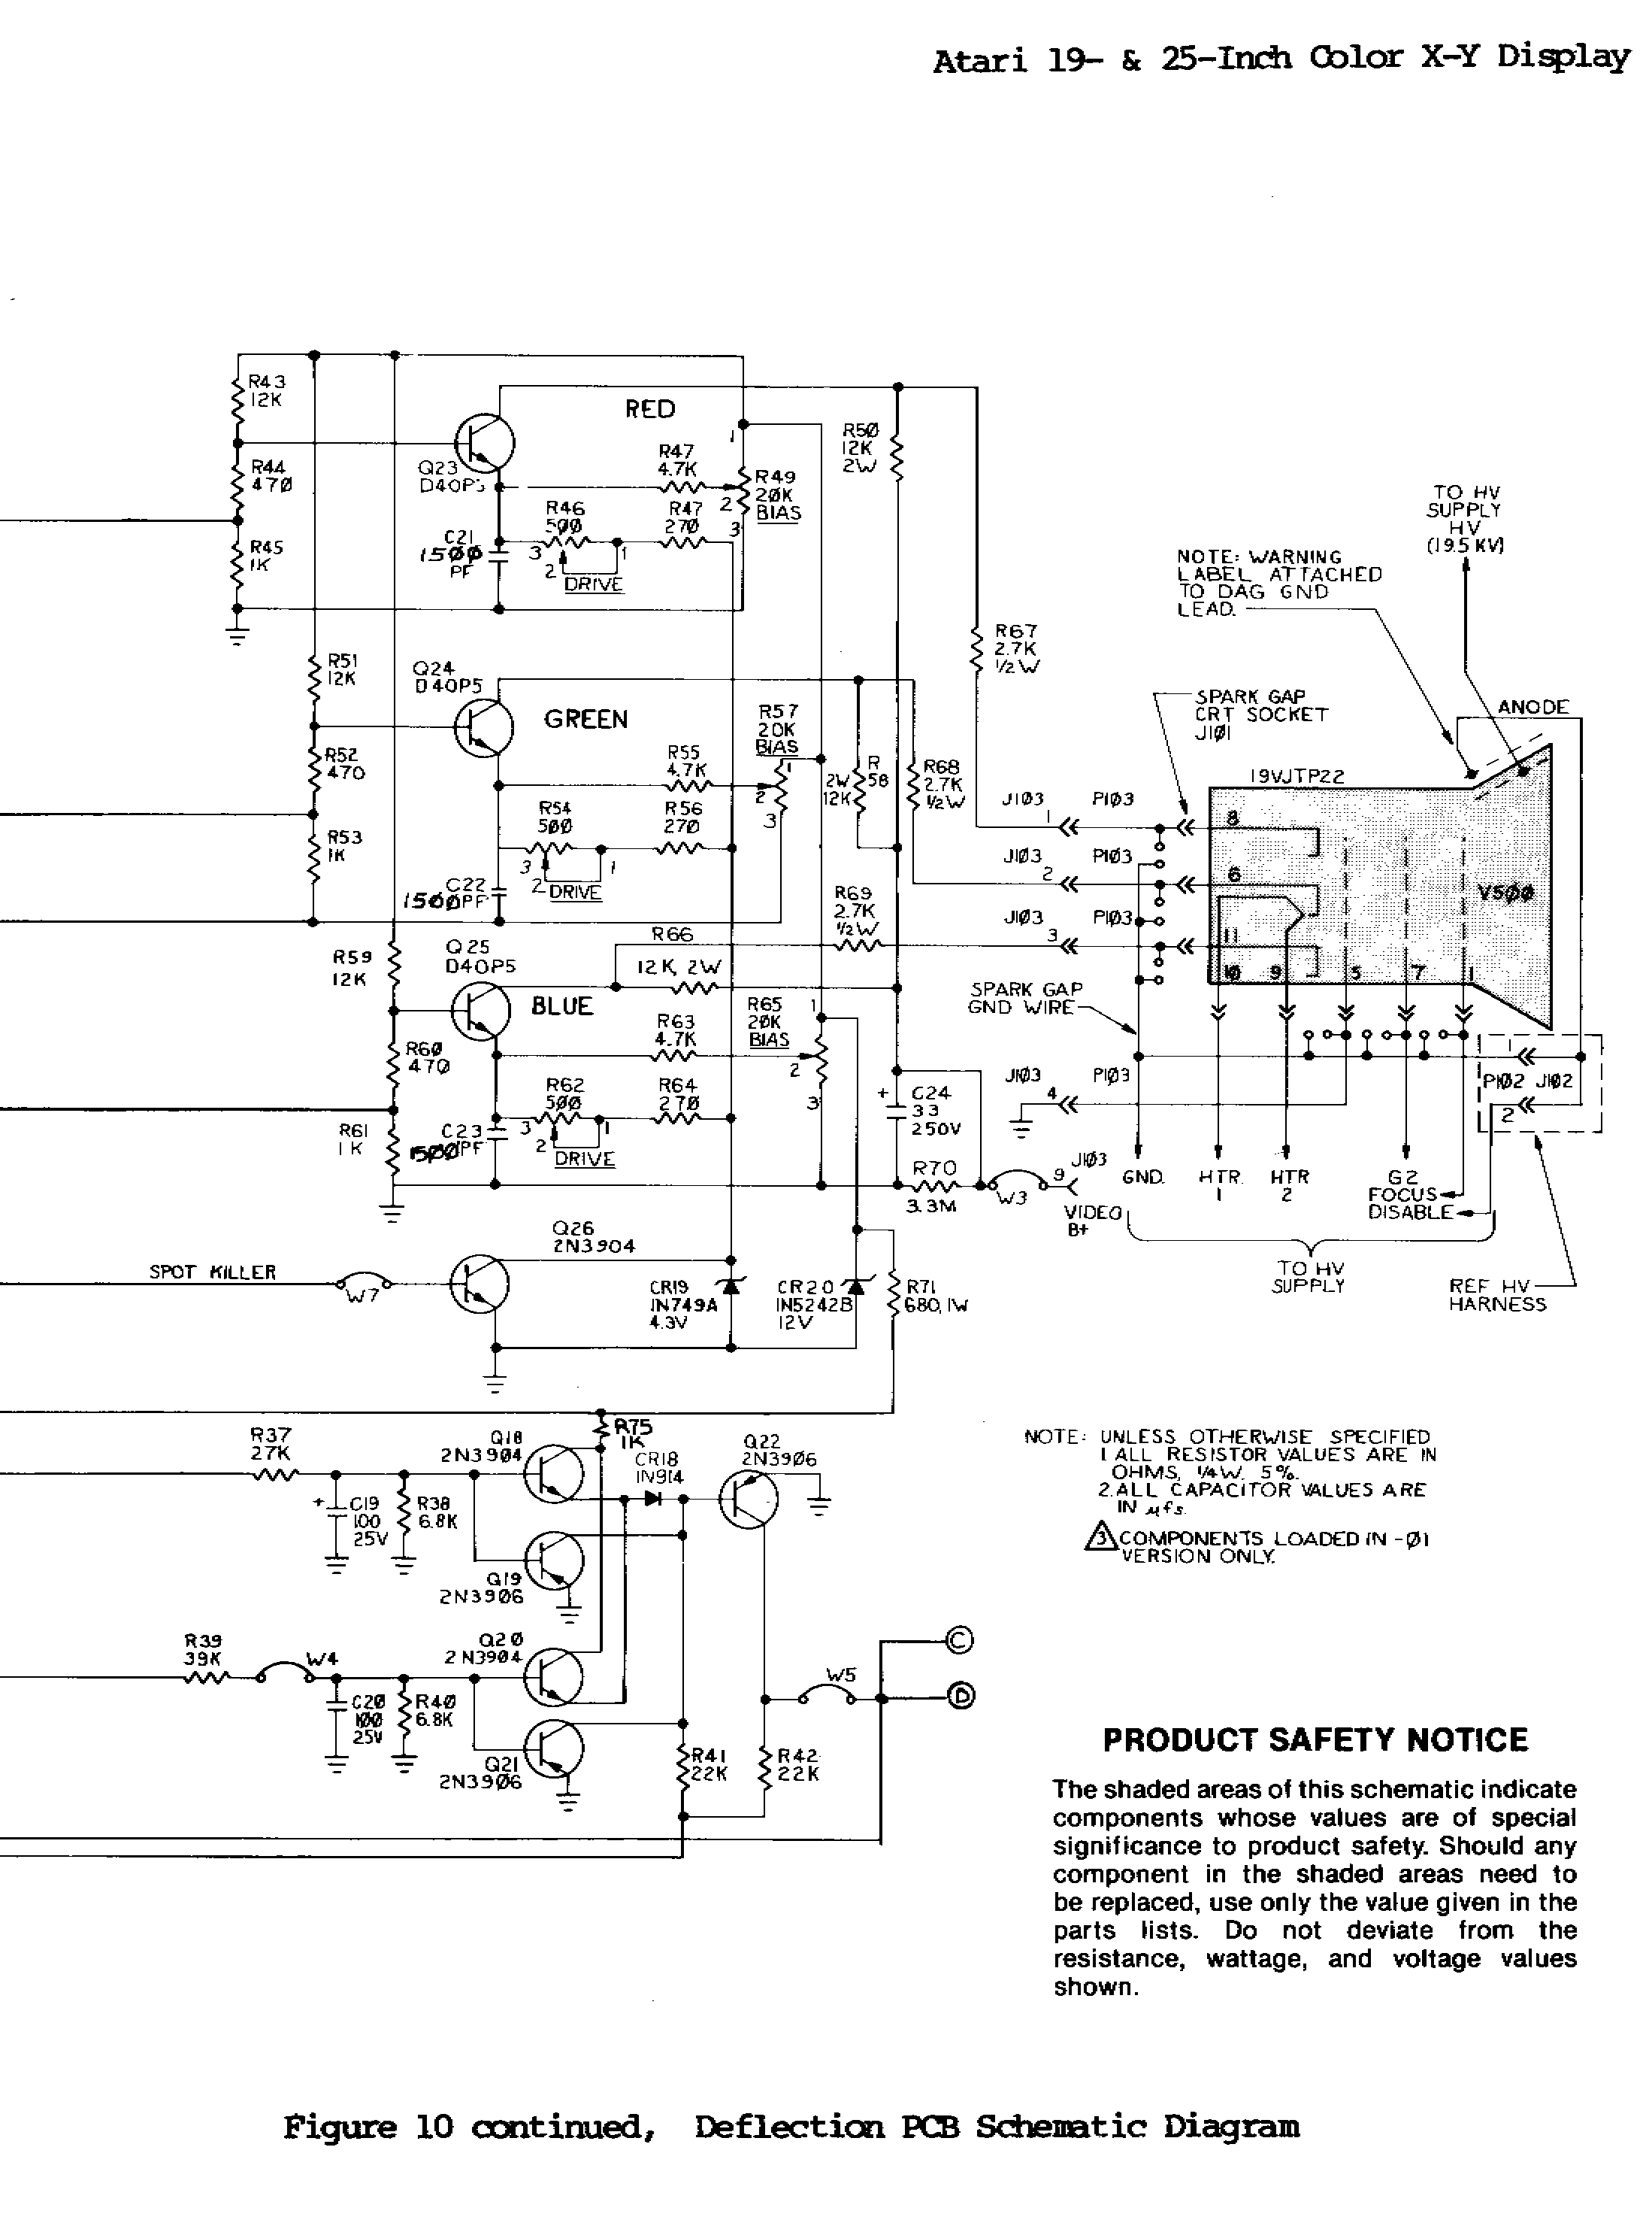
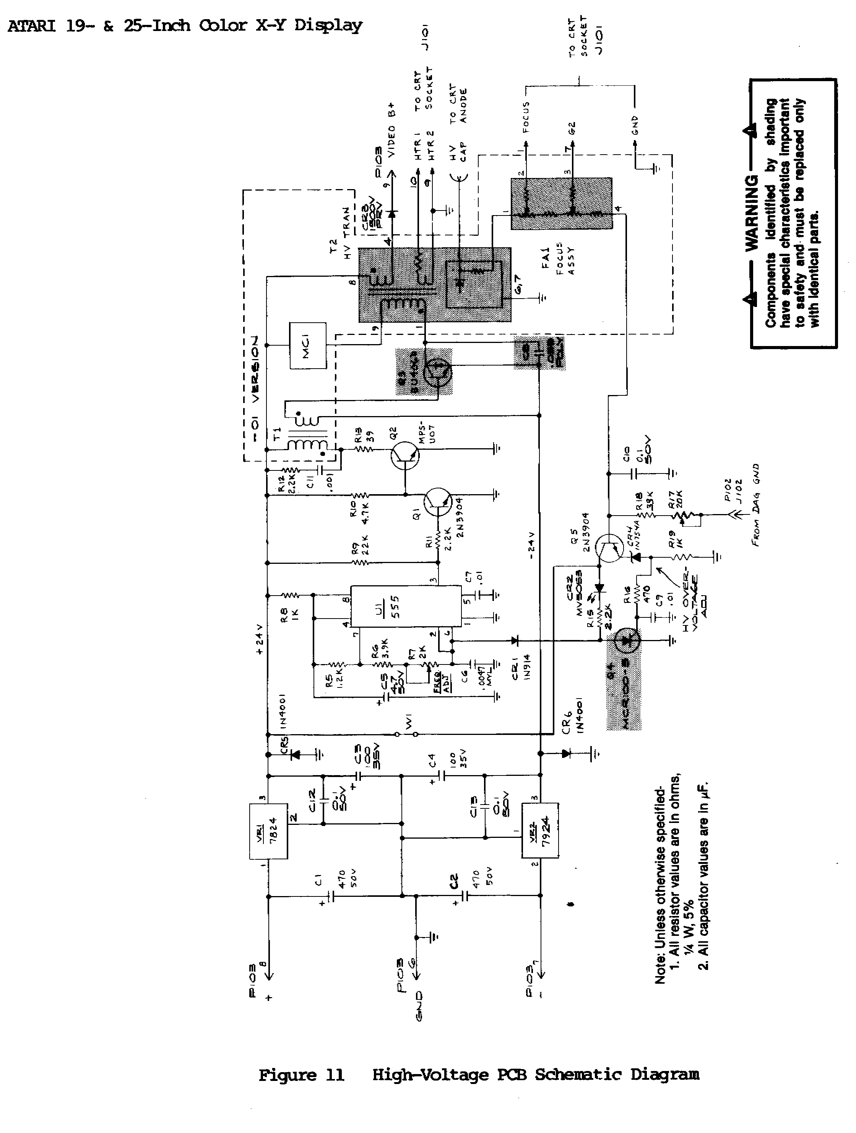

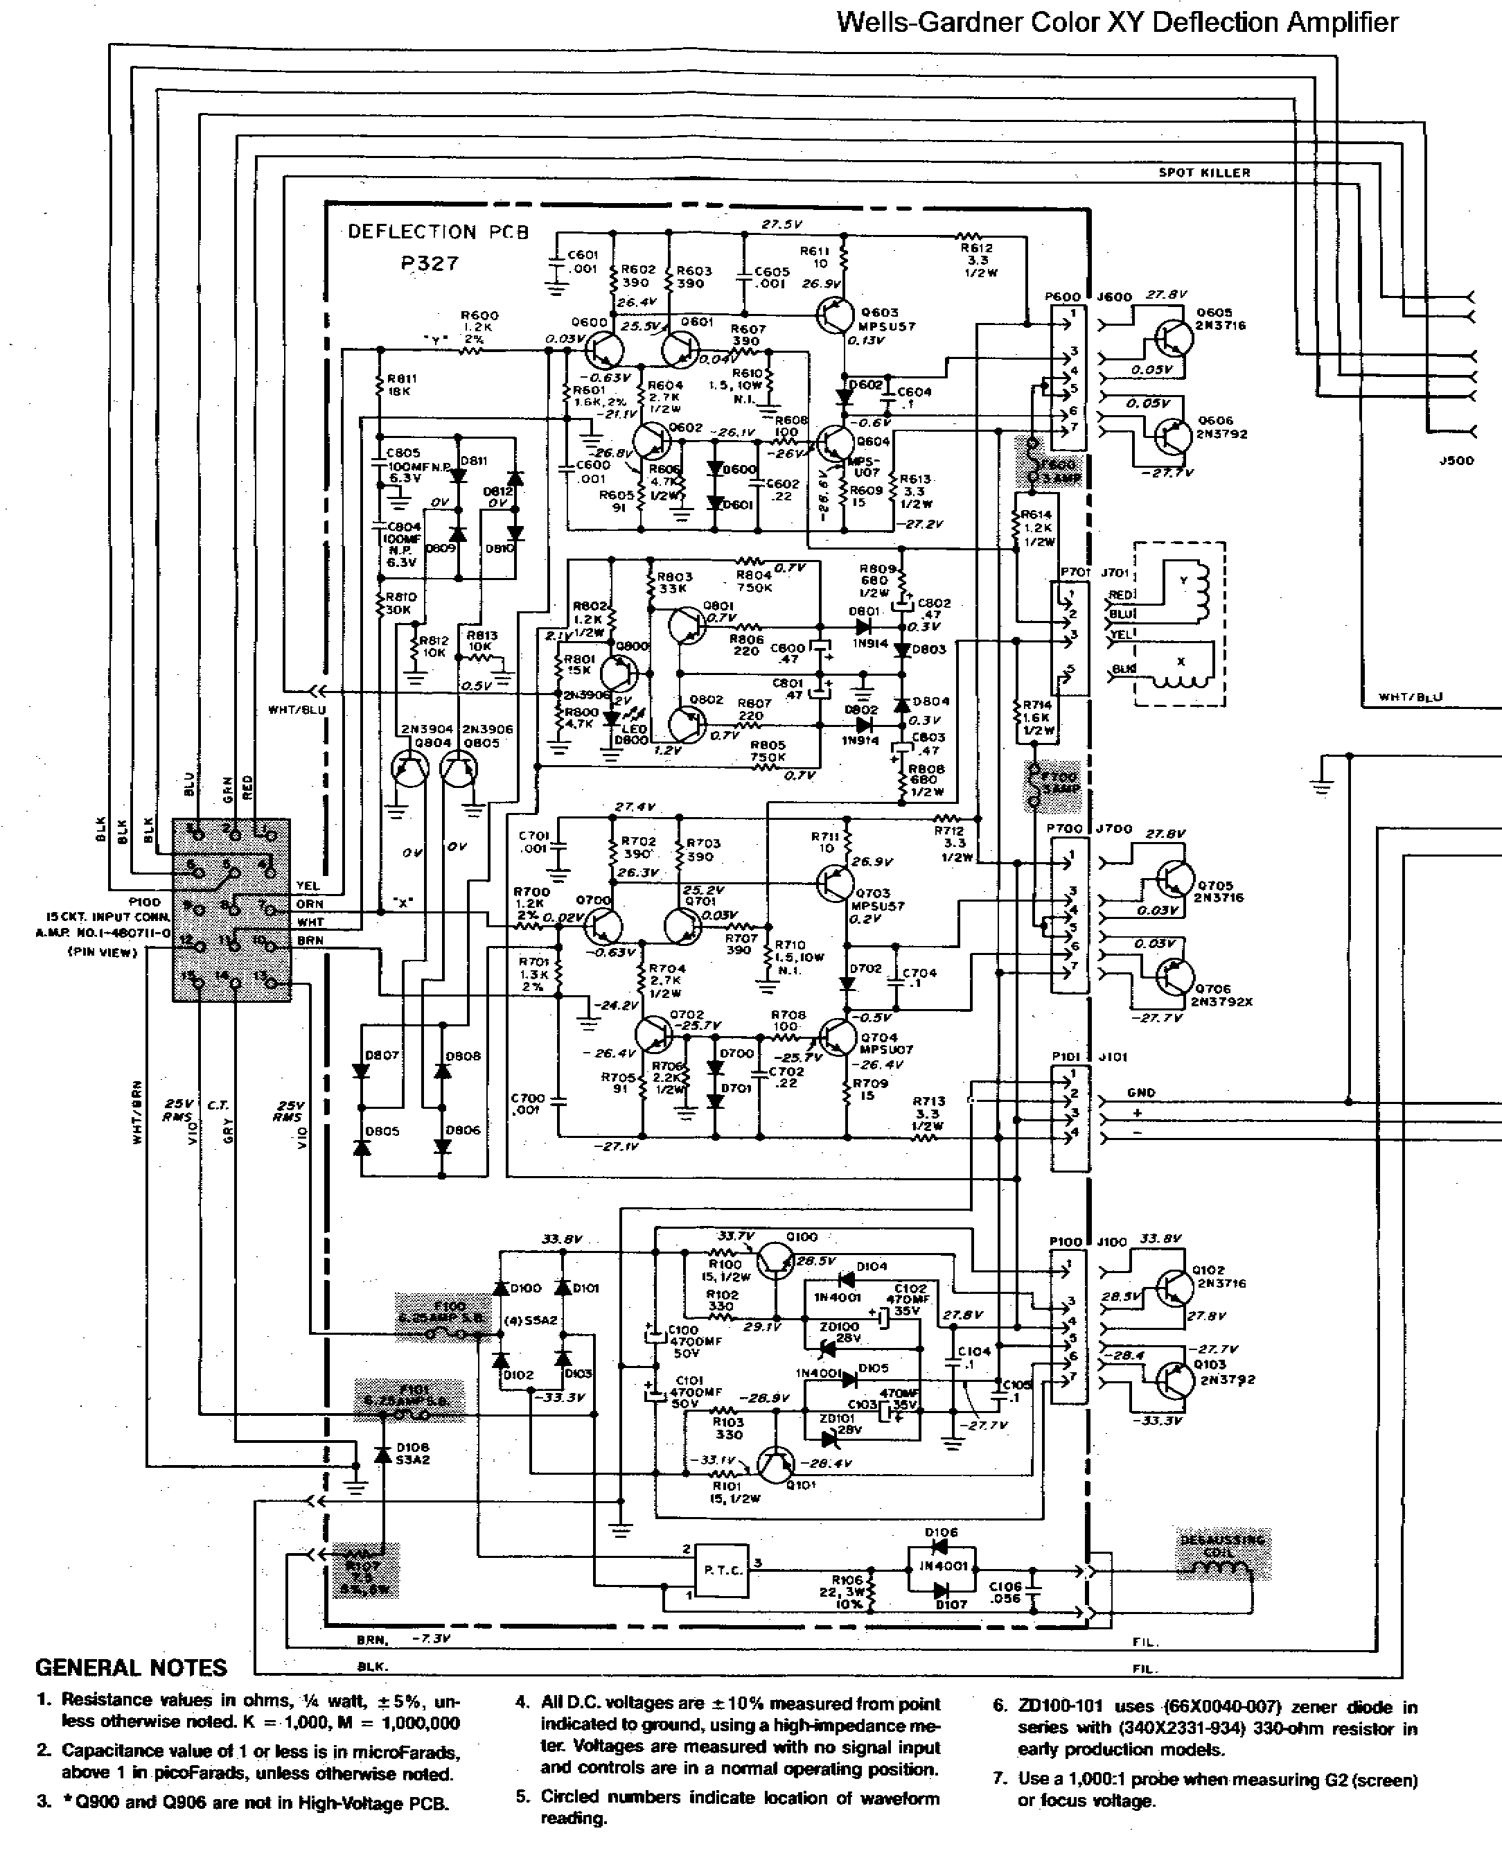
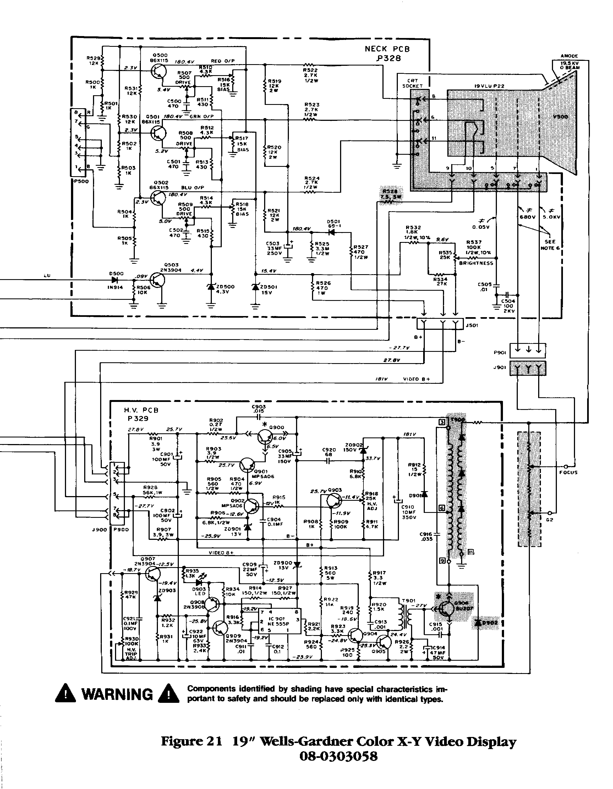High Voltage Power Supplies

By now everyone has heard the story of the Universally-Hated Atari Executive who went down to Brownsville to visit Amplifone, ignored requests not to smoke inside the building, and triggered the fire sprinklers, ruining every Amplifone HV transformer ever made. While there was never any shortage of Universally-Hated Atari Executives, and while an incident of this type could have happened, I have my doubts about it. For one, I didn't hear about it until I saw it on the Web about two years ago, long after I left Atari Games.

The story I heard, while I was still at Atari, was that the method used to make the HV transformers turned out to be sensitive to humidity, and the first HV transformers to burn up were the ones made during hurricane season. However, most of the others eventually followed.

Very likely, the real story is simply that the potting material used in the transformers was not up to the task.

Regardless of the cause, by the time the problem appeared the Operators had already made a good return on their investment. That was good news for the Operators but bad news for those of us trying to keep their 17 year-old Star Wars games alive.

I've had two Amplifone HV transformers burn up in my TomCat game. I finally replaced the HV assembly with one from a Wells-Gardner monitor. The only difference is that the Wells-Gardner supply does not provide 6.3VAC for the CRT heater. (I put in a 6.3VAC filament transformer.)

The HV supply in my Star Wars game still works fine, although the game does not have all that much flight time logged.

For the record, I was the Project Engineer on Star Wars, but I didn't design the monitor. (I certainly didn't design the High Voltage Transformer.)

Let's start at the beginning.

When televisions were first made in the late 1940s the high voltage power supplies used transformers that operated from the line at 60 Hz. I know, because I had one. (My father knew the owner of the TV repair shop in town and I would periodically get junk TVs to take apart. People left them because they decided they weren't worth fixing/adjusting. Some were left because they were just old.)

Screens were small (a 10 inch screen was common) so the high voltage was probably only 10 KV. The problem was that filtering the 60 Hz output required a large high voltage (10 KV) capacitor. One of the reasons that 60Hz was chosen as the vertical sync rate was so that 60 Hz hum would not be as noticeable.
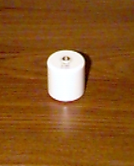
Eventually, someone got the idea to use the horizontal frequency (15,750 Hz) to produce the high voltage using a flyback transformer. Operating at the higher frequency meant you could use a lower value capacitor. The standard high voltage capacitor was 500 pF. It was called a doorknob capacitor because that's what it looks like. This is what a modern doorknob capacitor looks like. >>>>>>
Connections are made with screw terminals on the top and bottom. The old TV doorknob capacitors were usually beige/orange and had ridges around the cylinder.

Nowadays they coat both the inside and outside of the CRT envelope with a conductive material, forming a capacitor. The inside coating connects to the HV connector and the outside coating is grounded. The capacitance ends up being about 2000 pF. (Don't "clean" it off.)

The way a flyback transformer works is that you charge it with current (relatively slowly) and then release it all at once. That's because, in an inductor, the voltage developed across it is proportional to the rate of change of the current:
V = L * di/dt

The flyback transformer is charged during the active horizontal time (50 us) and discharged as a Big Zap during Horizontal Sync (about 8 us). (When you add front and back porch blanking you end up with 63.5 us, which is the horizontal period.)

A further feature is that the charging of the inductor also provides the current ramp for the horizontal deflection coils.

The voltage still needs to be stepped up, so there is a secondary winding. The output of the secondary winding is then rectified by a diode that is usually encapsulated inside the flyback transformer and filtered by the capacitor that is built into the CRT.

The Big Zap occurs during Horizontal Blanking. Any sagging of the HV also occurs at the horizontal rate and is not as noticeable as if it occurred randomly during active video.

The problem with XY is that there is no Horizontal Sync, so the Big Zap occurs randomly in the vectors. Actually, the Big Zap occurs at regular intervals, it's from the vectors' point of view that it occurs randomly.

The conventional wisdom is that the HV Supply for an XY Monitor must generate a sine wave to avoid this problem. The manual for the Electrohome B/W XY Monitor explicitly mentions that it uses a sine wave circuit.

I heard of a Collector who tried a television HV Supply in his Star Wars. According to someone who saw it, it exhibited noticeable (and ugly) Vector Beating. It appeared that the only way to fix a burned-up Amplifone HV transformer was to buy an expensive replacement from Wintron.

Now I'm not so sure.

In the process of putting this article together I put an oscilloscope on the Wells-Gardner HV Supply in my TomCat. Since I don't have a special (and expensive) high voltage probe, I looked at the collector of Q906, the transistor that drives the HV transformer. (The schematics for the Wells-Gardner HV Supply are in the previous section.)

What I got is shown in Figure 21. It doesn't look like a sine wave to me.
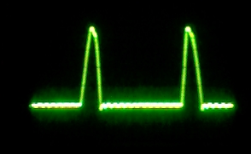

Figure 21

Wells-Gardner Color XY High Voltage Supply
Waveform at Q906 Collector

Voltage = -24VDC to +250VDC.
Time Between Pulses = 52 us.
Pulse Rate = 19.2 KHz.

The fact that there is 250V anywhere on a primary winding in a circuit powered by 48V (-24V and +24V) is a dead giveaway that it is operating in flyback mode.

Besides, even with a sine wave, when you rectify it and use a capacitive-input filter, you get a Big Zap.

I performed a further experiment using a Philips Mono VGA Monitor (model 7BM749CH01). This is a B/W monitor that combines the RGB signals and runs at VGA Sync frequencies.

I connected the HV output (probably 15 KV) to the anode of the CRT in my TomCat. The monitor started life as a stock Amplifone monitor so the CRT is probably a 19VJTP22. I left everything else (Heater, G2, and Focus) connected to the Well-Gardner supply.

There was just enough range in the Focus control to adjust to the lower anode voltage.

Unfortunately, the results were not definitive

1. The screen was noticeably dimmer, as you would expect with a lower anode voltage. (Increasing the G2 voltage made it impossible to focus the beam.)

2. There was some Vector Beating in the game, but if I hadn't been looking for it, I wouldn't have noticed it (at least not right away). It didn't interfere with the game.

3. Vector Beating was more evident in the test patterns, especially the Cross Hatch pattern. The Philips supply was operating at around 16 KHz. Increasing the frequency had some effect on the beat pattern, suggesting there was an interaction between the HV from the Philips supply and the G2 (and focus) from the Wells supply. I suspect that operating all the CRT voltages from the same supply would reduce vector beating and that operating at a higher frequency (like 32 KHz) would give better results. (When I increased the frequency of the Philips supply the HV decreased, making it impossible to focus the beam.)

This suggests that the HV supply from an old computer color monitor (with a schematic) might be used to power color XY monitors. The requirements are:

1. Either the High Voltage supply must be isolated from the power line or an isolation transformer must be used.

2. Either the circuitry that shuts down the monitor in the absence of sync must be disabled or a simple sync generator must be constructed (two 555s producing 32 KHz and 60Hz respectively).

3. Any electrical pincushion correction must also be disabled. Since the Horizontal Deflection coils are intimately involved in the high voltage circuit, any modulation of the Horizontal coils will probably also modulate the High Voltage. (I wonder if the problem when the Collector used a television High Voltage supply in his Star Wars was due to the presence of a pincushion correction circuit. Someone with a high voltage probe and a spectrum analyzer is invited to investigate this aspect further.)

If necessary, the outputs (anode, focus, and G2) could be filtered by adding capacitors or by changing to an inductive-input filter. (The filtered voltage would be less, but might be enough.)

A final word on High Voltage Supplies.

When an electron beam is accelerated at a target at energies above 25KV it starts to produce ionizing radiation, commonly known as x-rays.

In the 1960s, as sales of color TVs took off, manufacturers started using high voltages as high as 30KV - 35KV in order to produce brighter pictures. Either the manufacturers didn't know they were producing x-rays or they didn't care. Perhaps they decided that the amount of x-rays was small compared to the dose everyone was already receiving from nuclear fallout produced by the atmospheric testing of nuclear bombs. (And in the 1950s, shoe stores had x-ray machines to allow you to look down and see how well your shoes fit.)

People (especially parents) were concerned, and the Government finally did something about it. Today, TVs are not permitted to produce high voltages in excess of 25 KV, and protection circuitry is required so that failure of a single component (or any single-point failure) will not allow the voltage to rise above 25 KV.

Now a special treat for Amplifone junkies.

I was present at the first meeting Atari had with Amplifone. It took place when we were in Sunnyvale at 1272 Borregas. The first thing Ted Handing (Jr.) did was give each of us a notebook filled with information about Amplifone. (Mine was numbered 0053). I remember Ted as a big, friendly guy who kind of reminded me of Hoss Cartright. (If you don't know who Hoss Cartright was, ask your parents.)

I still have the notebook. Here is the first page.
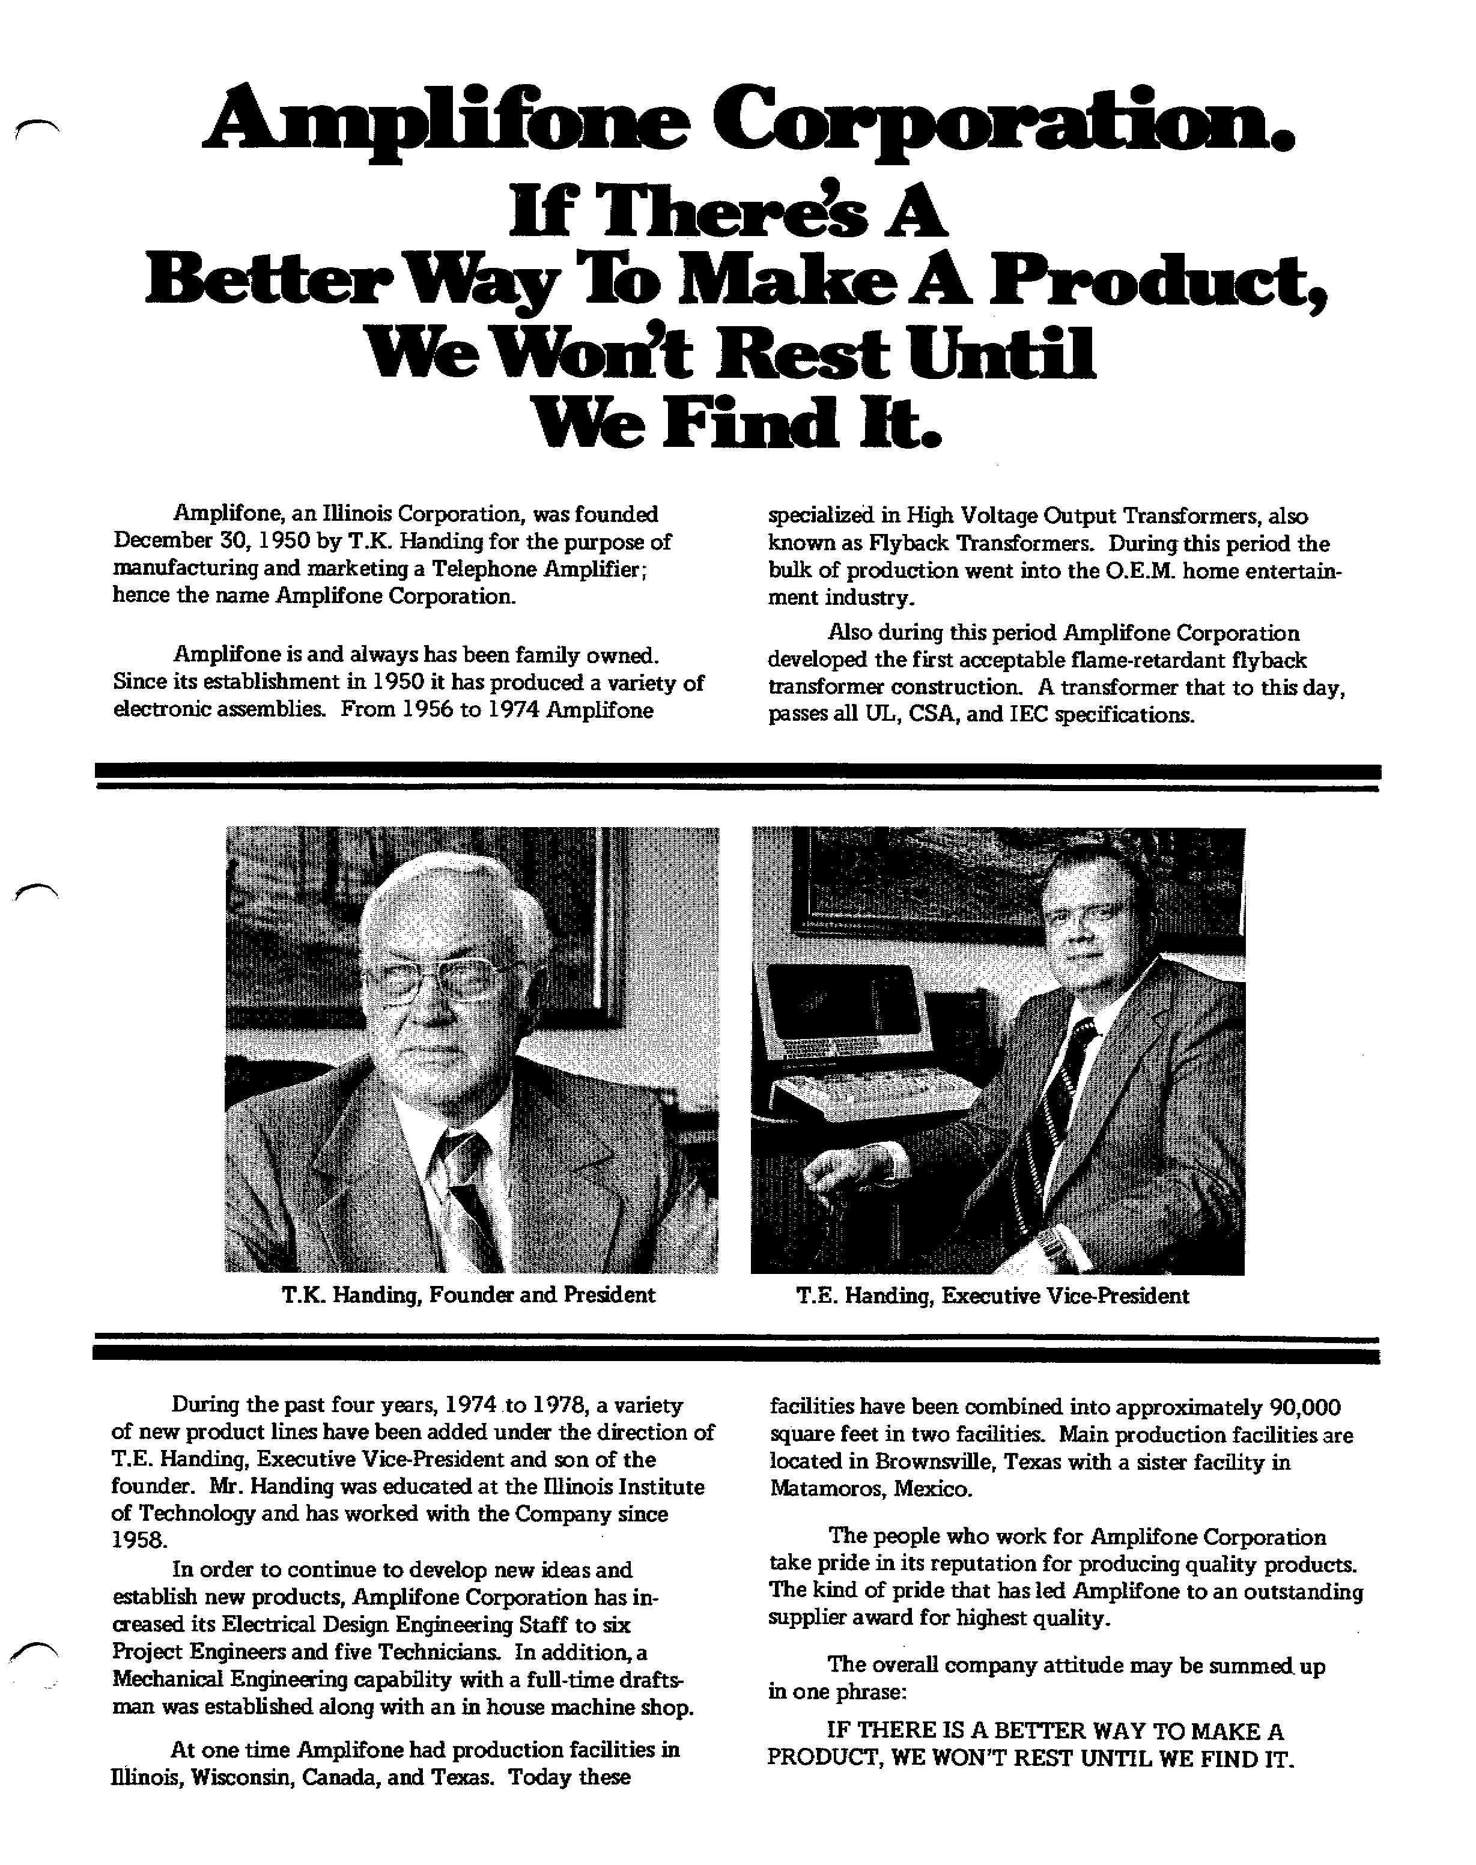
You can download the whole notebook here. Warning, it is 9.2 MB (PDF). (I will keep it available until I need the Server space for something else.)

Screen Phosphors

We now have an Electron Gun producing an Electron Beam, accelerated by the High Voltage on the Anode, and with the ability to move the Electron Beam around by using the Deflection Amplifiers to control the current in the Deflection Coils.

Since we cannot see the Electron Beam directly, the face of the CRT is coated with a Phosphor which absorbs the energy of the electrons and re-emits it as visible light. This process is called cathodoluminescence.

Phosphors are generally light metals such as zinc and cadmium in the form of sulfide, sulfate, and phosphate compounds that are processed to produce very fine particles which are deposited on the screen.

A thin (100 to 300 nm) metal layer (usually aluminum) is then deposited over the phosphor coating with the following benefits:

1. The reflecting aluminum surface reflects the light that would otherwise go to the back of the CRT, thereby doubling the amount of light that comes out the front.

2. It prevents the phosphor from being charged by the electron beam. Before the technique of aluminizing the phosphor was developed, the phosphors had to be formulated to facilitate the secondary emission of electrons, which compromised the phosphors' performance.

3. It protects the phosphor from being damaged by ion-bombardment.

Ion-bombardment has an interesting history. We will start with two questions.

1. Why are there ions in my CRT? Ions are present from a combination of having an imperfect vacuum and from outgassing of the materials used in the CRT.

2. Why are ions a problem? Negative ions (being negative) are accelerated toward the screen just like electrons. However, because ions are so much heavier they don't get deflected very much (if at all). As a result, they all end up in the center of the screen where they cause the phosphor to deteriorate. Generally (at least in a B/W CRT) it causes the phosphor to turn brown. This is very noticeable, kind of like a phosphor burn.

When TV sets were first offered for sale (at the 1939 World's Fair) they ranged from $200 to $600, which represented several months of an average worker's salary. Screen sizes ranged from 5-inches to 12-inches and because the technology at that time did not permit wide deflection angles, the pictures tubes were long. So long, in fact, that in the larger-sized models the devices were mounted vertically. A hinge-mounted mirror at the top of the receiver cabinet permitted viewing. Having the CRT in their expensive TV develop an ion spot would have pissed people off. (Note: the development of television was interrupted by the Second World War and did not really start until the War was over.)

The first solution to the problem was to mount the electron gun crooked, so that it was aimed at the neck instead of the screen. Since the CRT neck was relatively long, this did not require much of an angle. A magnet mounted on a ring around the neck straightened out the electron beam. The ions, being much heavier, do not get deflected and continue on to hit the neck where they can do no harm. The magnet that does this is called the ion-trap, and was one more thing that was fun to play with.

Aluminized phosphor screens were developed in the late 1940s, but there were many TVs manufactured in the 1950s that continued to use ion-traps and old phosphors.

A final word on the aluminized layer. Although it is electrically conducting, it is thin enough that it does not interfere with the electron beam exciting the phosphor.

There are several important characteristics of phosphors.

One is the color (obviously).

The property of light emission during phosphor excitation is called flourescence. The property of emission immediately after excitation is called phosphorescence. For most phosphors, the color emitted by flourescence and phosphoresence are the same. However, there are some for which this is not the case.

Another important characteristic is persistence, which is the time it takes for light emitted from the screen to decay to 10% of its maximum value.

A long persistence time is used when the screen update rate is slow, such as in the Planned Position Indicator (PPI) used in old radar displays. Of course, if you update it frequently, it smears.

The persistence time for the phosphors used in CRTs intended for video is characterized as Medium-Short.

There is a list of standard phosphor types going from P1 - P41. Only a few are used in standard products, such as P22 (R,G,B Color) used in color television and video and P4 (White) used in B/W televisions. P1 (Yellow-Green) is (or was) common in oscilloscopes; the Tektronix 465 used P31 (Green) with P11 (Blue) as an option.

A P7 phosphor is Blue in flourescence (when the beam is hitting it) and Yellow in phosphorescence (after the beam stops). The two colors also have different persistence times. Blue is Medium-Short while Yellow is Long. That's probably why it was used in radar.

Special purpose long phosphors like P7 are probably obsolete since it is now easier to use a standard raster display and simulate the required effects in software. In 1999 Tektronix ran a series of ads announcing they had invented something they called "Digital Persistence" which was a method for simulating the decay characteristics of an analog CRT on a digital system. It turns out they were a bit late to the party. Atari developed the method for the radar display in Subs (released in 1977).

The following is list of the standard phosphors. It comes mostly from Whitaker; however, I have corrected the mistakes he made in defining persistence times. (All of the microseconds were mislabeled as milliseconds.)

Phosphor List (from Whitaker)

Color* Persistence** Intended Use
Fluorescent Phosphorescent
P1 YG YG M Oscillography, radar
P2 YG YG M Oscillography
P3 YO YO M
P4 W W MS Direct view television
P5 B B MS Photographic
P6 W W S
P7 B Y MS(B) L(Y) Radar
P8 replaced by P7
P9 not registered
P10 dark trace screen VL Radar
P11 B B MS photographic
P12 O O L Radar
P13 RO RO M Radar
P14 B YO MS(B), M(YO) Radar
P15 UV G UV(VS), G(S) Flying-spot scanner
P16 UV UV VS Flying-spot scanner, photographic
P17 B Y S(B), L(Y) Oscillography, radar
P18 W W M-MS Projection television
P19 O O L Radar
P20 YG YG M-MS Storage tube
P21 RO RO M Radar
P22 (R,G,B) (R,G,B) MS Tricolor video (television)
P23 W W MS Direct-view television
P24 G G S Flying Spot Scanner
P25 O O M Radar
P26 O O VL Radar
P27 RO RO M Color TV monitor
P28 YG YG L Radar
P29 P2 and P25 stripes Radar, indicators
P30 Cancelled
P31 G G MS Oscillography, bright video
P32 PB YG L Radar
P33 O O VL Radar
P34 BG YG VL Radar, oscillography
P35 G B MS Oscillography
P36 YG YG VS Flying-spot scanner
P37 B B VS Flying-spot scanner, photographic
P38 O O VL Radar
P39 YG YG L Radar
P40 B YG MS(B), L(YG) Low repetition rate (Pl 2 and Pl 6)
P41 UV O VS(UV), L(O) Radar with light trigger

* Color: B = blue, P = purple, G = green, O orange, Y = yellow, R red, W white, UV = ultraviolet

** Persistence to 10% decay level:
VS (Very Short) = less than 1 us
S (Short) = 1 us to 10 us
MS (Medium-Short) = 10 us to 1 ms
M (Medium) = 1 ms to 100 ms
L (Long) = 100ms to 1s
Color CRTs

If this is a monochrome (B/W) CRT we are done.

But a color CRT uses three phosphors and a method for exciting each one separately. There are two different ways of arranging the phosphors.

In the Delta method there are triads of three dots arranged in a delta configuration, as shown in Figure 22a. Three are also three electron beams arranged in a delta configuration. Directly in front of the phosphor screen is the shadow mask, with a single hole in front of each phosphor triad. The geometry is such that the Red electron beam only sees the Red phosphor dot. The Shadow Mask shades the Green and Blue dots in the triad from the Red electron beam. Similarly, the Green electron beam only sees the Green phosphor dot and the Blue electron beam only sees the Blue phosphor dot. See Figure 22b. (Of course, this assumes that everything is perfectly converged.)

The advantage of the Delta Gun is that it allows the phosphor dots to be placed close together (smaller pitch). The cost is that convergence is more difficult because the electron beams are not in the same plane and are therefore affected slightly differently by the magnetic fields used to move them around. Convergence is also more demanding because it doesn't leave much room for error.

In the second method, called the In-Line method, the phosphors are arranged in triads of three phosphor stripes as shown in Figure 23a. The electron beams are arranged side-by-side and the shadow mask has a slot in front of each phosphor triad. See Figure 23b.

While the In-Line Gun produces a larger pitch, having the electron beams in the same plane makes them more uniformly affected by magnetic fields. The slot also leaves allows more room for error.

There is a good reason why the slots are vertical instead of horizontal. I realized this one day when I was evaluating the color purity of a monitor. The monitor was on a wheeled cart and was oriented with the screen vertical but with the long side up, like in Centipede. I had a pure red screen displayed. For some reason it was necessary to move the cart, and in the process it got turned 90 degrees. All of a sudden I was looking at a pure blue screen. I thought to myself, "what's the deal?" (I wasn't running Windows.) I turned the monitor back to its original position. It was red again. I looked around to see if this was the work of some prankster but I was the only one there. I turned the cart several times and always got the same result. That's when I realized what was going on.

Unless you are located in the extreme Northern or Southern latitudes, the Earth's magnetic field is mainly horizontal. Remember that a horizontal magnetic field deflects an electron beam vertically. That means that when a monitor is oriented normally, the Earth's magnetic field moves the electron beams within the vertical slots so it doesn't screw up monitor purity. As a result, degaussing is not as critical.

If the monitor is mounted ala Centipede, you lose that advantage.

Alternatives

Alternative #1 - Use A/Ds (probably at least 20 MHz) on X, Y, R, G, B, stuff the data into a frame buffer, and display it on a raster monitor.

Hardware:
A/Ds: 10-bit A/Ds on X and Y
8-bit A/Ds on R, G, and B

Frame Buffer: two buffers of 1024*768*24 bits = 4,718,592 bytes. To avoid awkward line boundaries, use
two buffers of 1024*1024*24 bits = 6,291,456 bytes = ~ 6 MBytes

Control: FPGA for memory control and video sync, maybe DSP for frame rate conversion

Hardware Issues:

Nowadays, most of the interesting components seem to be Surface Mount Devices (SMDs). SMDs are generally difficult (or impossible) to prototype, require multilayer PCBs (at least four layers), and the PCBs require a solder mask. PCBs of this type are expensive, especially in prototype quantities. The specialized equipment for soldering SMDs is also expensive.

Software issues:

If the raster refresh rate is different from the vector refresh rate the screen data will not be properly displayed.

The screen refresh rate for Star Wars is about 24 ms (42 Hz). That rules out standard NTSC monitors. It's also too slow for Computer monitors. However, computer monitors may be able to run at twice that rate (84 Hz). Interpolating between frames is possible to perform scan conversion, but requires considerable processing and never looks all that good anyway.

There is also the latency problem. Digitizing the signal would require that you fill a buffer before you display it. That means that the picture you see will be at least one refresh frame behind, which will be at least 12 ms. The latency time in an interactive system is critical, and even a 12 ms delay will be enough to make the controls appear sluggish.

I'm not saying this method is impossible, just that it could be very difficult.
_____________________________________________________________________________________

Alternate #2 - Use a Flat Panel Display, which is inherently XY Addressable.

Although Flat Panel Displays such as LCDs, Plasma Displays, and Field Emission Displays (FEDs) are inherently XY addressable, the driver ICs are generally integrated on the panel, making it difficult to modify.

That's a shame, since the panel interface would only need an X Register, a Y Register, and three color registers. (The digital signals would come from A/Ds.)

Since the pixels would be written in real time with no buffer, there would be no added latency.

Alternative #3 - For the Future

There is considerable work being done on Organic Semiconductors, especially Organic LEDs, especially to make Flat Panel Displays. Think of Organic Semiconductors as Plastic. One big advantage is that the processing is done at much lower temperature than that used to make traditional semiconductors. They are talking about using a manufacturing technique similar to ordinary printing. This is expected to bring the cost of Flat Panel Displays way down.

If the process becomes very cheap it may be possible to have prototypes made for a reasonable cost.
Of course, our prototypes will have the X,Y,R,G,B inputs we need.

Perhaps, one day, we will be able to buy our own inexpensive printers and make our own panels, as well as processors and memory.

_____________________________________________________________________________________

References

Video Display Engineering by Jerry Whitaker, McGraw-Hill, 2001. {If you want to learn more about this subject this is the one to buy, even though it costs $80. They also have a Web site at www.tvhandbook.com }

Basic Television Principles and Servicing by Bernard Grob, McGraw-Hill, 1975.

Electronic Components Handbook by Thomas H. Jones, Reston Publishing Company, 1979.

Fundamentals of Display Systems Design by Sol Sherr, Wiley Interscience, 1970
{ When I bought this book in the 1980s I paid $35.50 for it. A second edition was published in 1993 and costs $180.00 on amazon.com . I don't think I'll buy it.}

Principles of Electron Tubes by Herbert J. Reich, originally published in 1941. Reprinted by Audio Amateur Press 1995. { This is a great book if you are interested in vacuum tubes.}
________________________________________________________________________________________

Copyright 2001 Jed Margolin

